Possible points:

* Did not consider under-reporting in model
* Possibly extend framework to more specific causes and/or lifetime risk due to limitations of the mmr measurement itself
  + 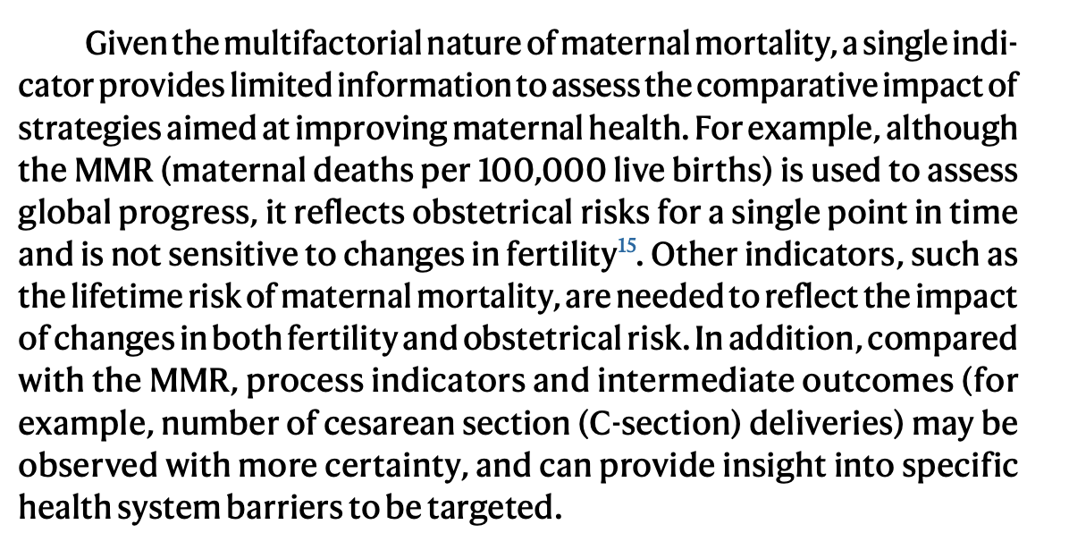
    - <https://www.nature.com/articles/s41591-023-02310-x>
  + Especially with respect to late maternal deaths

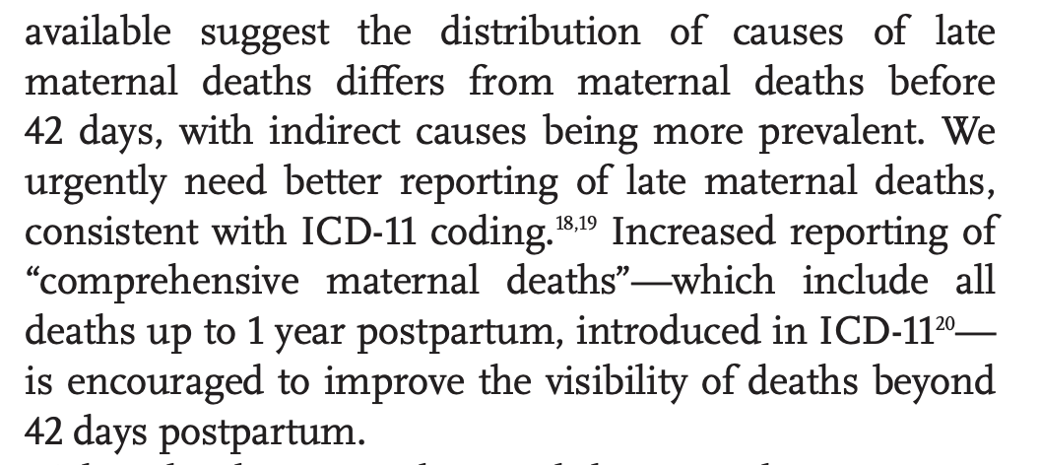

<https://www.clinicalkey.com.au/service/content/pdf/watermarked/1-s2.0-S2214109X24005606.pdf?locale=en_AU&searchIndex=>

* + Could also use it to expand cause of death for maternal deaths due to suicide

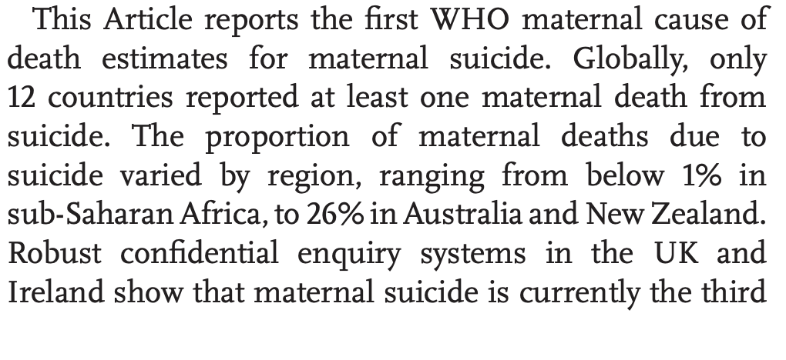

* + - same article as above point
* Primarily, this study relied exclusively on data from the World Bank database, which, though extensively used and recognized for its reliability, may not wholly encapsulate the intricacies and nuances of MMRs across the diverse African continent. The reliability and completeness of the World Bank’s MMR data could potentially vary across countries and regions within Africa due to the disparities in data collection, reporting standards, and healthcare infrastructure. Consequently, our analysis might be subject to some degree of imprecision.
  + Also use as a limitation for my study
  + ARIMA Africa study’
* Interesting extention: what if we used completely unsupervised machine learning to do cluster analysis
  + Lose fine-grained, but will potentially gain in not needing data subject to misreporting?
* Other studies finding that missing data imputation would be better than just splitting
  + <https://www.sciencedirect.com/science/article/pii/S0020025515001838#s0085>

reason for using Bayesian methods was to incorporate uncertainty, which I do not do

* <https://pmc.ncbi.nlm.nih.gov/articles/PMC4196216/#S5>

<file:///Users/rosalitarosenberg/Downloads/16-AOAS1014%20(2).pdf>

